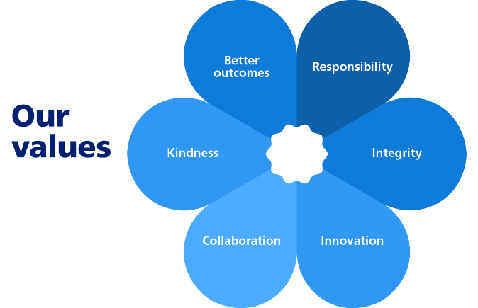
b

JOB TITLE: Refuse Driver/Chargehand
SALARY POTENTIAL: £28,142 - £31,537
£31,120 - £35,058 (if working 8 bank holidays)
What is the role?

You will drive and be fully responsible for our Refuse Collection Vehicles. You will supervise your Crew Members in providing a front-line service which works hard to improve the environment of the Borough.

You will:
- As a member of a team, undertake duties associated with the collection, loading, transportation & disposal of household, recycling, garden and commercial waste.
- Supervise, guide and direct your crew, making sure they follow health and safety rules and safe systems of work at all times.
- Undertake waste loading duties at every opportunity that is reasonable.
- Act in a professional manner and respond to issues raised by householders concerning the waste collection service.
- Conduct daily vehicle safety checks before use, following transport procedures
- Complete paperwork and offer written feedback information (Bin Hangers) to householders
- Assist other crews in collection, loading, transportation and disposal duties
- On any day when you are not undertaking driving duties you will undertake other duties as required by your Manager.

You must make sure that you follow our procedures and Health and Safety rules.

You must remember that you represent the Council in all that you do.

You must speak to customers and colleagues in a helpful and polite way.

You will sometimes be required to undertake training and attend meetings outside of your normal working hours.

Who is the Person?

It is important to us that you have:
- A full, clean, LGV and full valid driving licence
- An understanding of waste and recycling collections
- A good level of physical fitness
- Flexible, willing and able to work unsocial and additional hours when required
- A nice way of speaking to our customers
- The ability to get on well with your team
- A sense of pride and commitment to do a good job
- Common sense and good judgement
- The ability to work in all weathers

August 2025
Our policy is to make adaptations for those who have substantial and long term disabilities. If you need an adaptation to carry out any of the above please let us know.

