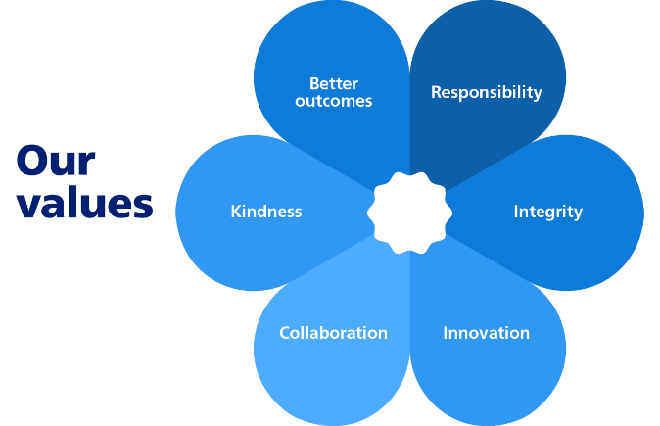

**JOB TITLE:** Holly Hill Rediscovered Project Officer

**SALARY:** £34,751- £38,460 (£17,375 - £19,230 pro rata 2.5 days a week)

**CONTRACT:** Fixed Term – 12 months

**What is the role?**

To support the Head of Streetscene in delivering the Holly Hill Rediscovered regeneration project working with the appointed design team and the Council’s internal project team. This role will be based at Council Depot in Broadcut, Fareham and will be required to travel to other locations in the Borough for consultation and engagement including site visits to Holly Hill Woodland Park.

**Specifically, you will:**

* Assist with the management of the detailed design stage of a major landscape regeneration project for Holly Hill Woodland Park, Fareham
* Produce ideas for engagement activities for residents and businesses in order to promote the regeneration of Holly Hill and generate ideas and activities for improvements from those involved
* Assist with delivering engagement and consultation for the Holly Hill project
* Ensure the efficient capture and retrieval of complete and accurate project records
* Be the principal day to day link between the Council and the appointed design team
* Carry out periodic monitoring and reporting of the Holly Hill project including reporting to the National Lottery Heritage Fund (NLHF) against agreed and documented time and budget targets while ensuring appropriate quality standards are maintained
* Assist in the design and management of the Holly Hill project webpages to ensure residents and businesses in Fareham have access to up to date information
* Assist with Economic Development, Leisure and Community and Communications initiatives for the project
* Co-ordinate an ongoing programme of internal and external meetings and events
* Ensure that the complete and checked project archive is delivered to the Head of Streetscene at the completion of the detailed design phase

You will have an understanding of, or interest in, landscape, ecology regeneration and place making and working with businesses, elected Members of the Council, communities and residents to promote the project proposals, and provide support across the Council to help deliver the project for the successful regeneration of Holly Hill Woodland Park.

**It is important to us that you have:**

* A passion for place making and creating great places for people to live, work and visit
* The ability to think creatively to help provide solutions to problems
* Excellent communication and analytical skills
* Budget monitoring and administration skills
* The ability to build valuable relationships with both internal and external customers, and the ability to deal with customers and colleagues in a helpful and polite manner
* Enthusiasm and drive to move projects forward and see them through to completion
* The ability to proactively prioritise and manage your workload
* Good ICT skills including website management
* Political Awareness
* A sense of pride and determination to do a good job
* A customer orientated approach
* A full driving license and access to a suitable means of mobility

**It is desirable to us that you have:**

* Have good knowledge of project delivery, ideally related to landscape design or public realm

**Last Updated: May 2025**